Final Project Proposal

The shader I want to make is a comic book/toon shader. There will be edge detection to make outlines for all objects, very slight waves on those lines to make it look like its hand drawn, a cross-hatching texture to use instead of regular shadows.A drawing of a ball and a stone wall

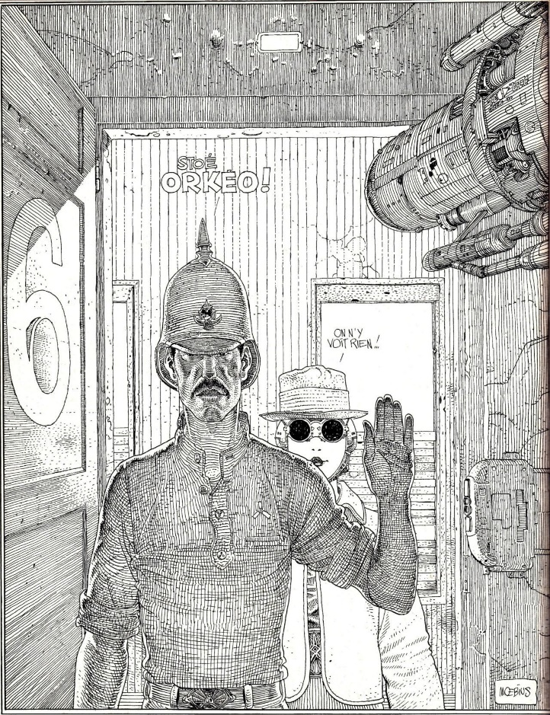The shader is based off this video: [Moebius-style 3D Rendering | Useless Game Dev (youtube.com)](https://www.youtube.com/watch?v=jlKNOirh66E)

